1. COVER
Project: Maui Surf House
Name: Lexter Cortez
Island: Maui
Visitor Segment: Australians coming to Maui to surf
Version: v3 – Sep 13, 2026
GitHub: https://github.com/cortezlb-coder/ics385spring2026/tree/main/week15/term-project
Live URL: [Render URL]

2. PROBLEM STATEMENT & TARGET USER

Problem Statement
Australian surfers visiting Maui need a simple way to view surf-friendly lodging, amenities, tourism information, and current weather without searching across multiple websites. Maui Surf House combines this information into one application.

Target User
The primary user is an Australian surfer visiting Maui who wants quick, easy-to-read property and travel information. The secondary user is the property admin who needs secure access to update the property listing.

3. FUNCTIONAL REQUIREMENTS

R1 - Display Maui Surf House property information and at least 3 surf-friendly amenities
R2 - Display Maui tourism statistics and current weather using 3 charts
R3 - Support local email/password authentication
R4 - [NEW v3] Support Google OAuth 2.0 authentication
R5 - Protect admin pages and property-editing routes
R6 - Allow authenticated admins to update property information in MongoDB
R7 - Allow authenticated users to log out and end their session

4. TECHNICAL ARCHITECTURE

Stack
- Frontend: React
- Backend: Node.js and Express
- Database: MongoDB and Mongoose
- Authentication: Passport.js Local and Google OAuth 2.0
- Sessions: express-session and connect-mongo
- Charts: Chart.js
- Weather: OpenWeatherMap API

Request Flow
React Frontend → Node.js/Express → MongoDB / External APIs

React requests property and authentication data from Express. Express uses Mongoose to read and update MongoDB. Chart.js displays Maui tourism data and OpenWeatherMap supplies current weather information.
Property Schema
- name: String
- island: String
- type: String
- description: String
- amenities: String[]
- targetSegment: String
- imageURL: String
- reviews: Review[]

Review Schema
- guestName: String
- rating: Number, 1-5
- comment: String
- date: Date

Component Data
- Hero: propertyName String, island String, imageURL String, tagline String
- About: description String, location String, targetSegment String
- Amenities: amenities String[]
- CTA: buttonLabel String, buttonHref String
- Dashboard: property Property, tourismSeries Array, weather Object, weatherStatus String
- AdminLoginPage: email String, password String, errorMessage String
- GoogleSignInButton: buttonLabel String, authURL String
- AdminDashboard: property Property, editFields Object, saveStatus String
- AuthStatus: currentUser Object/null, sessionState String

The dashboard displays three charts: Visitor Arrivals, Hotel Occupancy, and Weather Forecast.

COMPONENT HIERARCHY
App
├── MarketingPage
│ ├── Hero
│ ├── About
│ ├── Amenities
│ └── CTA
├── Dashboard
├── AdminLoginPage
│ └── GoogleSignInButton (V3)
├── AdminDashboard
└── AuthStatus / Logout

5. AUTHENTICATION & SECURITY

Authentication
The application supports local authentication using email and a bcrypt-hashed password and Google OAuth 2.0 using passport-google-oauth20. Local login provides a standard option while Google Sign-In provides a faster alternative.

User Data Model
- email: String, required, unique
- displayName: String
- passwordHash: String, optional for Google users
- googleId: String, unique and indexed
- provider: String, local or google
- role: String
- createdAt: Date

Account Linking
Google authentication first searches for an existing googleId, then a matching verified email. If neither exists, a new user is created in MongoDB.

Session Management
Sessions use express-session with connect-mongo and expire after 14 days. Cookies use httpOnly, sameSite "lax", and secure cookies in production.

Secret Handling
Secrets are stored in a git-ignored .env file and .env.example contains only placeholder values. Environment variables include MONGO_URI, SESSION_SECRET, GOOGLE_CLIENT_ID, GOOGLE_CLIENT_SECRET, OPENWEATHER_API_KEY, NODE_ENV, and PORT

Protected Routes
- GET /admin/dashboard - authenticated admin only
- PUT /admin/properties/:id - authenticated admin only
- POST /auth/logout - authenticated users only
Unauthenticated users requesting the admin dashboard are redirected to /login. Unauthorized API requests receive HTTP 401 or 403.

Security Threats
- A01 Broken Access Control - authentication and role checks protect admin routes
- A02 Cryptographic Failures - bcrypt protects passwords and .env protects secrets
- A07 Identification and Authentication Failures - Passport.js and secure sessions protect login

6. ACCEPTANCE CRITERIA & TEST SCRIPTS

AC-1 Marketing Page
GIVEN a visitor opens Maui Surf House / WHEN the page loads / THEN the property name, Maui location, image, description, and at least 3 surf-related amenities are displayed

AC-2 Visitor Dashboard
GIVEN a visitor opens the dashboard / WHEN it loads / THEN Visitor Arrivals, Hotel Occupancy, and Weather Forecast charts display non-empty data
AC-3 Local Login
GIVEN a registered admin has valid credentials / WHEN the login form is submitted / THEN the admin is authenticated, a session is created, and the protected dashboard can be accessed

AC-4 Google Login
GIVEN a user has a Google account / WHEN Google authentication is completed / THEN the user is authenticated and the account is created or linked with a Google ID

AC-5 Protected Dashboard
GIVEN a visitor is not authenticated / WHEN the admin dashboard is requested / THEN the visitor is redirected to /login and no admin data is shown

AC-6 Property Update
GIVEN an admin is authenticated / WHEN property information is changed and saved / THEN the update is stored in MongoDB and remains after refresh

AC-7 Logout
GIVEN a user is authenticated / WHEN logout is selected / THEN the session ends and protected routes can no longer be accessed

AC-8 Secret Hygiene
GIVEN the GitHub repository / WHEN it is inspected / THEN .env is absent, .env.example is present, and no private API keys are committed

Automated Tests
- AC-3: valid local login creates an authenticated session
- AC-4: Google OAuth route redirects the user to Google authentication
- AC-5: unauthenticated users cannot access the admin dashboard
- AC-6: authenticated admins can update property information
- AC-7: logout ends the session and blocks protected routes

Test Output
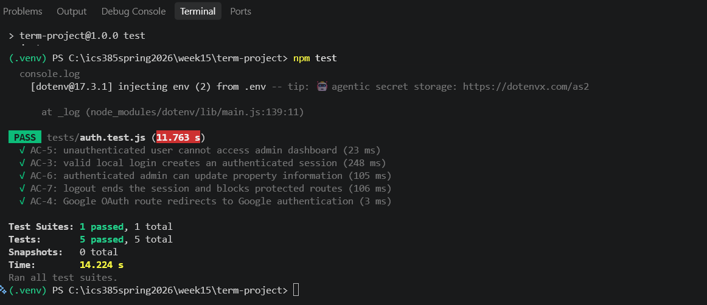

7. AI ATTRIBUTION

ChatGPT was used only to edit grammar, wording, organization, and formatting. Project requirements, design decisions, and acceptance criteria were created and reviewed by the student.

